
A 10
Sreenidhi Institute of Science & Technology
(An Autonomous Institution)
Code No: 101EC05/111EC05

B. TECH. I – Year II – Semester Examinations, June/July, 2012 (Regular/Suppli)
ELECTRONIC DEVICES AND CIRCUITS (Common to EEE, ECE, ECM)

Time: 3 Hours Max. Marks : 70

Note : No additional answer sheets will be provided.

Part-A (Objective Type)
Max. Marks : 20
Answer all QUESTIONS.

1. What is the need of providing a triggering circuit in CRO.
2. What is distortion in amplifier.
3. A signal diode has reverse saturation current of 2.5μA at 300⁰K. Find forward voltage for a forward current of 10mA.
4. What do you mean by tunneling effect?
5. Why is CC configuration seldom used?
6. How α and β of a transistor are related from each other.
7. In a JFET the drain current changes form 1.2mA to 1.5mA when the gate to source voltage is varied from -4.25V to -4.10V, keeping the drain - source voltage constant. Determine the trans conductance from the given JFET.
8. Define μ, r_{d} & g_{m}.
9. Give any one method to improve the gain of R-C coupled amplifiers at low frequencies?
10. What is the application of voltage multiplier.
Part – B
Max. Marks : 50
ANSWER ANY FIVE QUESTIONS. EACH QUESTION CARRIES 10 MARKS.

1. a) Explain in detail the construction and operation of a CRO. [ 7 ]

b) The x-deflection plates in a CRT are 20 mm long and 5 mm apart. The centre of the plates is 0.25 m from the screen. The accelerating voltage is 3,000V. Determine the deflection sensitivity and deflection factor of the CRT. [ 3 ]

2. a) Bring out the difference between the varactor diode and P-N diode. [ 5 ]

b) Find the voltage V_{A} of the circuit given in figure below. [ 5 ]
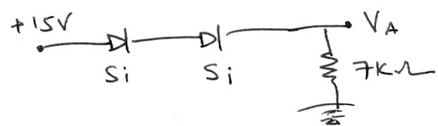

3. a) Assume that a silicon transistor with β = 50, V_{BE}=0.6V and V_{CC}=20V and R_{C}=4.7KΩ is used in a self - biased circuit. It is desired to establish a Q-point at V_{CE}=8V and I_{C} 2mA and stability factor S≤5.0. Design the circuit with all component values. [ 7 ]

b) Draw the h-parameter equivalent circuit of CE configuration. [ 3 ]

4. Draw the structure of a JFET and explain its principle of operation with neat diagrams along with its V-I characteristics. Define pinch-off voltage and mark it on the characteristics. Explain its significance in the operation of a JFET. [ 10 ]

5. a) Draw the frequency response curve of an R-C coupled amplifier and explain in details. [ 6 ]

b) Compare CC, CE and CB amplifiers. [ 4 ]

6. a) Show that in full wave rectifier the efficiency is 81.2% and ripple factor is 0.48. [ 7 ]

b) List out the specifications of voltage regulators. [ 3 ]

7. Write short notes on the following [5+ 5]
a) voltage doubler b) UJT

8. a) By using diode current equation explain P-N junction diode V-I characteristics. [ 6 ]

b) When a reverse bias is applied to get germanium P-N junction diode, the reverse saturation current at room temperature is 0.3μA. Determine the current flowing in the diode when 0.15V forward bias is applied at room temperature. [ 4 ]
-- 00 -- 00 --

